# **Tableau Script 2: Visualization and Functionalities**

**Problem Statement:** Analyze the factors that influence the sales and profit of the stores.

**Q1**. Relative % of **sales/profit** by region?

**Interaction:**

* How do you decide which chart or viz is to be used?
  + The answer lies in the question itself. When there is a **trend** to be displayed, you get the idea to use a **line chart**.
  + **Contribution + categories in %** will give you a hint of using a **pie chart**.
* Without any dimension/measure, we have a disabled pie chart.
* We bring relevant dimensions and measure on sheet & finally select pie chart.



* Let’s make this pie chart more labeled



* More than half of the work is done, but how do you add a **relative %**?
  + For that, we will **Quick Table Calculation**



* Regions could have any color, right? So can we make the color more intuitive?
* Can we dictate color on the basis of profit?
* Can we create a kind of heat map?



* We saw how color is governed by profit.
* Now can we govern the angle of the pie chart using sales? Let’s see how



**Q2**. Orders by region based on quantity sold

* The first chart that comes to mind is the **count plot**
* Since quantities can be large in numbers, we could **bin/group quantities**
* On the y-axis we have OrderId, but we will use a **distinct count** because we have **duplicate OrderId** in the dataset.
* Now, how do we bring orders **by region** in the chart?
  + Using **hue**

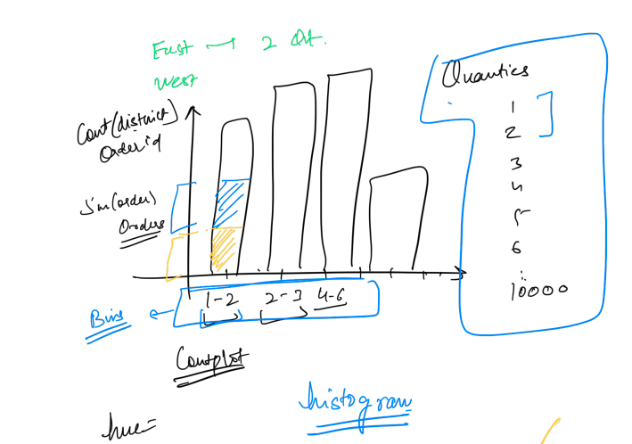

* Let’s take baby steps and first **create bins**



**Observation:**

* From a **measure** we **converted** quantity to **categorical**
* 2nd step is using **Count distinct on orderID**, how do you do that?
* Sometimes what happens there are too many fields in the table. So for example if you want to use orderID in the label. Instead of searching among many fields. If you used that field in the sheet, you select CNT(orderID) field + hold ctrl and drag and drop on the label.



* So we want to see orders by region



**Observation:**

* Sometimes you may not see labels, because they might be overlapping.

### **Functionalities in Tableau**

1. Aggregation
   1. Count
   2. Sum
   3. Avg
2. Groups
3. Sets
4. Parameter
5. Filter
   1. Data Source filter
   2. Quick filter
   3. Context filter

**Interaction:**

* Let’s start with Aggregation and see Profit Margin in different regions
  + What is Profit Margin?
    - Profit/Sales
* How do we calculate **Profit margin in excel**?



* But do you think after having a profit margin, can we take the sum of the profit margin % to get the entire profit margin?
  + Adding % like that doesn't make sense, right?
* We need to take the sum of sales for all rows, then the sum of profit for all the rows, and finally, **profit margin = total profit/total sales**
* Let’s see how we create a new field called **profit margin** in **tableau**.
  + This is done via a **calculated field.**



* When we see profit margins in different regions, we see tableau is adding them, which is not right.

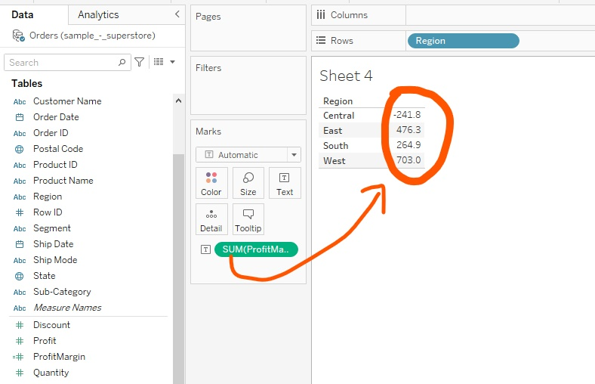

* How to correct profit margin % for each region?



* Let's do some coloring as well



**Q.** Compare the sales of small items(Binders, Papers, Fasteners, Envelopes) with the remaining items in the sub-category.

The total number of items in the sub-category is 12.

**Interaction:**

* What would be the approach to do it?
  + Group small items and then compare them with the rest of the 8 items
* Now see how it is done in tableau



* Finally, let's do the comparison



**Q**. Highlight the top three values in the **smallthings group** even if data changes in the same plot above.

* Keep that in mind we want to build something dynamic not static because if new data is added it might happen some other subcategories may occur in the top three sales.
* We will make it dynamic using **Sets**



**Q.** Get the top customers giving high revenue but low profit.

* The approach would be using sets.
  + Set A will be with customers with revenue & Set B will be with customers giving low profit, then taking an intersection.
* Let’s create a set for 100 customers by the top sales
  + The ones marked in blue are inside the set and the rest are outside the set



* Let’s filter out these customers inside the set and see their revenue



* Now we need another set of 100 customers giving the lowest profit
  + When we use this as a filter, we will get our **customers with high revenue but low profit**



* As we decrease the size(no of customers) of both sets that we created above, There will be a point where there is no **intersection**. So can we find that point?
* For this, we will introduce the **parameter**



* How do you connect/call the **parameter** to the previous sets that you created?



**Q**. How do you make cascading filters for state and city in the pie chart we made?

* Just **drag and drop city and state to filter** and **select all**. Finally, **show the filter**.



Observation:

* If I select Alabama as State, then also I am seeing cities from all US. I want to see the city for Alabama only.
* Now this could be resolved by **context filter**



**Observation:**

* Only relevant cities are shown for a particular state
* Finally build a dashboard out of the charts.
  + Explore the action filter under the dashboard

